Braj Kishor

2019HT13096@wilp.bits-pilani.ac.in

As Part of DBMS Assignment 1

Database Design Document.

ProQMan – Procurement Management Tool for Businesses

A Web based solution for Enterprises and Business to Manage their Direct and Indirect Procurements

Table of Contents

Context: 2

About ProQMan (Features): 2

What is Direct and Indirect procurement? 2

Important Terminology 2

ProQMan Application Solution details 3

Users of the system 3

User Load 4

Benefits of the Application 4

Entities in the system 5

ER Diagram of the system 6

Relational Model 7

Normalised Relational Model (BCNF) 8

Entity-Based Normalised Diagrams 9

User – Department – Role Entities 9

Purchase Requisition Entity 9

Purchase Order Entity 10

Goods Received – Payment Details 10

Supplier – Receipt Entity 11

Contract – Product Entity 11

SQL Queries 12

Create SQL: 12

Sample Insert SQL Statements 17

Sample Update SQL Statements 18

Sample Select SQL Queries 19

Indices On the Tables 21

Key Attribute Indices 21

Primary Keys 21

Unique Keys 21

Non-Key Indices 21

ENUMS 21

Additional Non-Key Indices which can Declared. 22

# Context:

This document details out Detailed Database design of the ProQMan solution. It contains the Details of Various Entities, ER Diagram, Relational Design and other details for the solution.

# About ProQMan (Features):

**ProQMan is a Web based solution for businesses and enterprises to allow them to manage their Direct and Indirect procurements.**

**The solution allows them to store, track and audit their procurement requests & orders, manage contracts with suppliers and provides pan organisation visibility in the procurement practices.**

**It also allows the cross sharing and collaboration of contracts and procurements across various sub units and division in enterprises.**

**The application additionally allows detailed reporting related to procurement expenses and supplier performances allowing companies to mitigate losses related to procurements.**

**The solution is web based and can be deployed on premise or in cloud and can be made available on the organisation’s Intranet.**

## **What is Direct and Indirect procurement?**

Direct procurement involves the purchasing of goods, materials, and services directly associated with the production of goods and services that a company is providing. Whereas, indirect spend refers to expenses incurred for materials, services, and maintenance required to operate the business. Both are important for a business, and one can’t exist without the other.

## Important Terminology

1. Contract: A deal between supplier and the organisation detailing out product and pricing details.
2. Purchase Requisition (PR): A purchase requisition is a form that an internal department of your company submits to the company’s purchasing department listing items it wants the purchasing department to order from an outside supplier.
3. Purchase Order (PO): Also known as a PO, the purchase order is a document outlining the details of an actual purchase. It contains details of product, quantity, delivery details etc and is sent to the external supplier.
4. Goods Received (GR): A GR document is generated once the product is received by the company. It contains details of delivery, quantity received, defects etc.

ProQMan Application Solution details

The solution is deployed as web application on the internal network of the organisation. It is a web-based solution with a central database system. The solution can be deployed on-premise or can be offered on cloud such as AWS as SaaS.

As the solution can contain sensitive and resource critical data, the solution uses Database Replication and encryption techniques. The database uses primarily an enterprise grade RDBMS system. Additional tools to ensure high availability and data caching is also used, which is not detailed in this document.

Users of the system

The system is designed to be used for procurement management and auditing. Following are the primary users of the system.

1. CPO (Chief Procurement Officer)
2. Procurement Managers
3. Procurement Executives
4. Category Managers
5. Category Analyst
6. Category Executive
7. CFO (Chief Finance Officer)
8. Finance Managers
9. Finance Auditors

In addition, the **System Administrators** also available whose role is support and maintenance of the system.

User Load

The main user base are the procurement and finance officers and analysts of the company. The solution is designed to be Single Instance per Organisation type solution. Depending on the size of the organisation, the number of users can vary from 50-1000 users and more.

Furthermore, the solution expects hundreds of concurrent users of the system.

Benefits of the Application

The key benefits are

1. Works as a central repository for supplier contracts across Organisation.
2. Allows easy tracking and auditing of procurement requests online.
3. Provides Visibility in procurement practices.
4. Allows dynamic reporting of Procurement expenses and supplier performances.
5. Allows the cross sharing and collaboration of contracts and procurements across various sub units and division in enterprises
6. Allows easy creation of Purchase Requisitions for any unit’s category analysts and manager.
7. Allows easy approvals of PR and creation of POs
8. Allows tracking of Goods Received, Online and Hard Copy Receipts, Delivery and other details etc for auditing.
9. Ease in Auditing for Finance teams.

# Entities in the system

**Described below are some of the Basic Entities of the system in the simplest form of the product.** However, the product can have additional entities and relationship as the complexity of the requirements increases.

1. Users: There are various types of users of the system. Each can have various types of roles and can be associated with different departments.
2. Roles: The various roles of the users in the company related to the solution.
3. Departments: The departments of the company. Different department has different category for consumables and hence different Category Analysts and Managers
4. Products: These contains the direct and indirect consumables of the organisation.
5. Contracts: The contract contains the pricing deals for various products between organisation and suppliers. It’s binding, however, may change upon consent as required.
6. Supplier: The vendor organisation which provides the product for procurement to the organisation. The supplier can be manufacturer, the whole seller or third party.
7. Purchase Requisition: The PR which is created by various departments for acquisition of the products. One PR may contain details of multiple products. It contains quantity required, purpose of the usage etc and is sent for approval.
8. Purchase Order: The PO is an approved PR which is sent outside to the supplier containing details of purchase request like order quantity, contract-based estimate, delivery estimates etc
9. Payment Details: The actual details of the payment made. This includes cost, payment made, payment mode and details like budget code etc. It also contains any prepayment details and refund details.
10. Receipt: The receipt document sent by the supplier. The document contains the total cost, discount, product, quantity, price and any payment details as per supplier. The details can be sent in hard copy or soft copy. The document is directly stored into the database after verification.
11. Goods Received: The details of the goods received by the organisation. This contains the products received along with quantity, Quality of the goods received, Goods returned, delivery details etc.

# ER Diagram of the system

Below is the preview of the ER Diagram.

**Please use this embedded high-quality image to zoom and see and the details.**



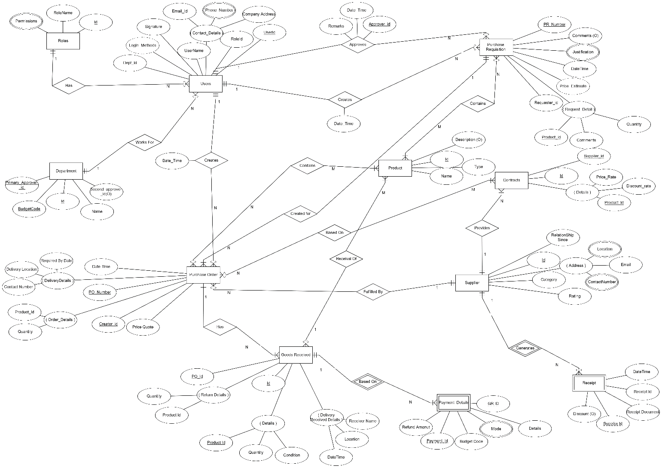

# Relational Model

Below is the preview of the Relational Model.

**Please use this embedded high-quality image to zoom and see and the details.**



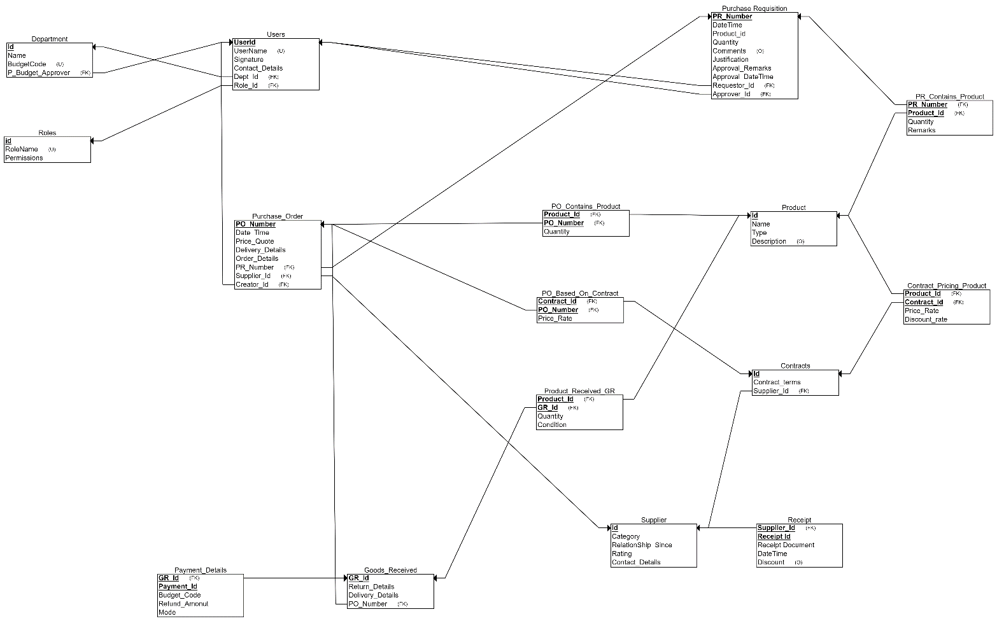

# Normalised Relational Model (BCNF)

Below is the preview of the Final Relational Model in BCNF.

**Please use this embedded high-quality image to zoom and see and the details.**



**Also, PFB the entity based Normalised Diagrams. The final image is aggregation of the all the entity-based images.**

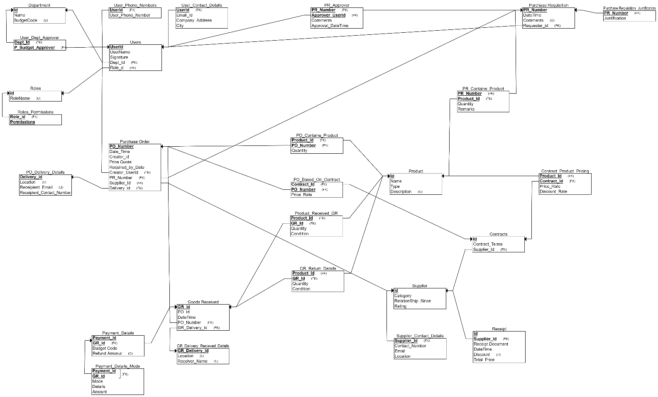

# Entity-Based Normalised Diagrams

User – Department – Role Entities

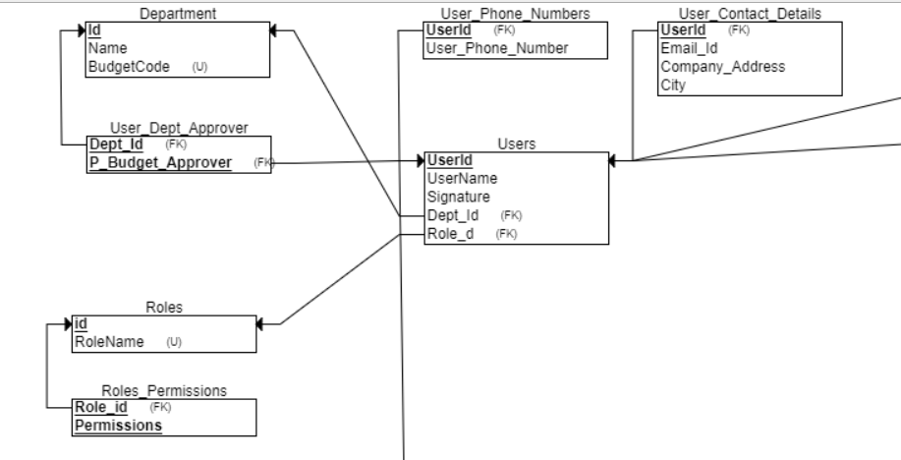

Purchase Requisition Entity

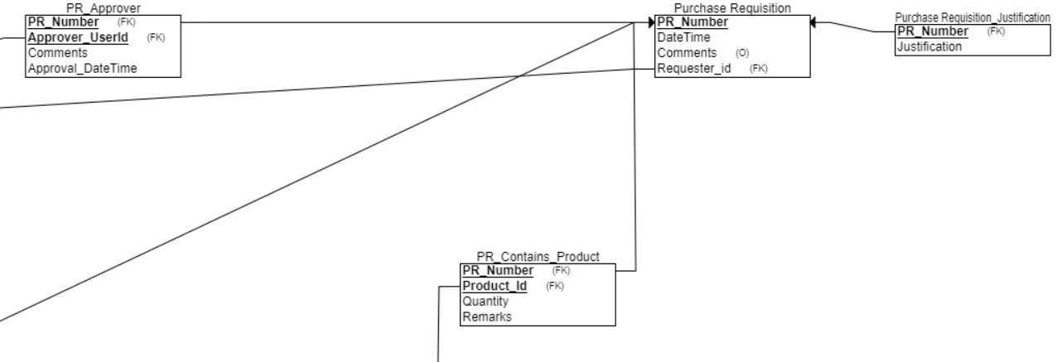

Purchase Order Entity

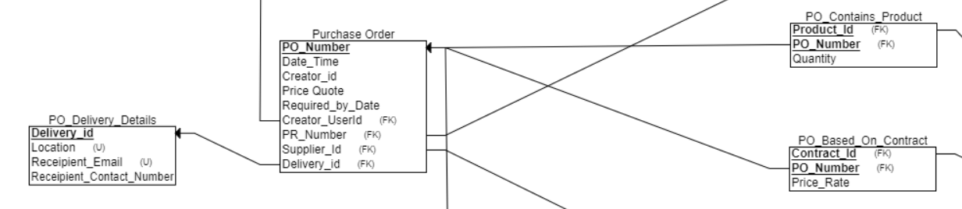

Goods Received – Payment Details

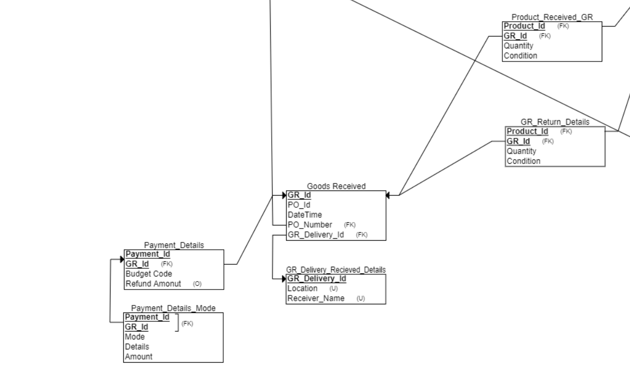

Supplier – Receipt Entity

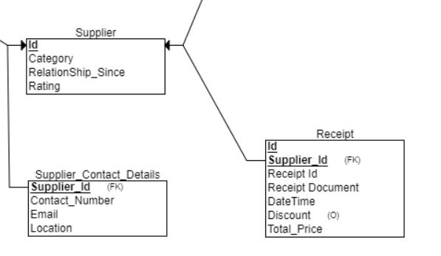

Contract – Product Entity

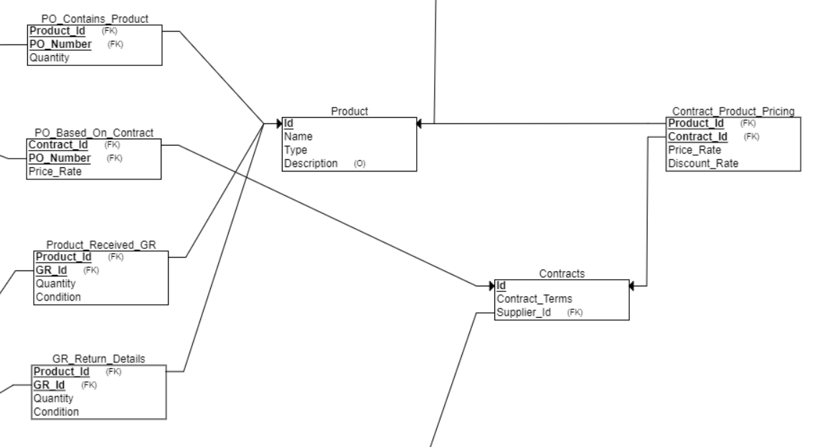

# SQL Queries

Create SQL:

**CREATE** **TABLE** Department

(

**Id** **INT** **NOT** NULL,

**Name** **VARCHAR**(50) **NOT** NULL,

BudgetCode **VARCHAR** **NOT** NULL,

PRIMARY **KEY** (**Id**),

**UNIQUE** (BudgetCode)

);

**CREATE** **TABLE** **Roles**

(

RoleName **ENUM NOT** NULL,

**id** **INT** **NOT** NULL,

PRIMARY **KEY** (**id**),

**UNIQUE** (RoleName)

);

**CREATE** **TABLE** Product

(

**Id** **INT** **NOT** NULL,

**Name** **VARCHAR**(100) **NOT** NULL,

**Type** **ENUM NOT** NULL,

Description **Text**,

PRIMARY **KEY** (**Id**)

);

**CREATE** **TABLE** Supplier

(

**Id** **INT** **NOT** NULL,

**Category** **ENUM NOT** NULL,

RelationShip_Since **DATE** **NOT** NULL,

Rating **INT** **NOT** NULL,

PRIMARY **KEY** (**Id**)

);

**CREATE** **TABLE** Receipt

(

**Id** **INT** **NOT** NULL,

Receipt_Document **Blob** **NOT** NULL,

DateTime **DATE** **NOT** NULL,

Discount **NUMERIC**,

Total_Price **NUMERIC** **NOT** NULL,

Supplier_Id **INT** **NOT** NULL,

PRIMARY **KEY** (**Id**, Supplier_Id),

FOREIGN **KEY** (Supplier_Id) **REFERENCES** Supplier(**Id**)

);

**CREATE** **TABLE** Roles_Permissions

(

Permissions **INT** **NOT** NULL,

Role_id **INT** **NOT** NULL,

PRIMARY **KEY** (Permissions, Role_id),

FOREIGN **KEY** (Role_id) **REFERENCES** **Roles**(**id**)

);

**CREATE** **TABLE** Supplier_Contact_Details

(

Contact_Number **INT** **NOT** NULL,

Email **VARCHAR**(50) **NOT** NULL,

Location **VARCHAR**(100) **NOT** NULL,

Supplier_Id **INT** **NOT** NULL,

PRIMARY **KEY** (Supplier_Id),

FOREIGN **KEY** (Supplier_Id) **REFERENCES** Supplier(**Id**)

);

**CREATE** **TABLE** PO_Delivery_Details

(

Receipient_Contact_Number **VARCHAR**(15) **NOT** NULL,

Location **VARCHAR**(50) **NOT** NULL,

Receipient_Email **VARCHAR**(50) **NOT** NULL,

Delivery_id **INT** **NOT** NULL,

PRIMARY **KEY** (Delivery_id),

**UNIQUE** (Location),

**UNIQUE** (Receipient_Email)

);

**CREATE** **TABLE** GR_Delivery_Recieved_Details

(

Location **INT** **NOT** NULL,

Receiver_Name **INT** **NOT** NULL,

GR_Delivery_Id **INT** **NOT** NULL,

PRIMARY **KEY** (GR_Delivery_Id),

**UNIQUE** (Location),

**UNIQUE** (Receiver_Name)

);

**CREATE** **TABLE** **Users**

(

UserName **INT** **NOT** NULL,

UserId **INT** **NOT** NULL,

Signature **Blob** **NOT** NULL,

Dept_Id **INT** **NOT** NULL,

Role_d **INT** **NOT** NULL,

PRIMARY **KEY** (UserId),

FOREIGN **KEY** (Dept_Id) **REFERENCES** Department(**Id**),

FOREIGN **KEY** (Role_d) **REFERENCES** **Roles**(**id**)

);

**CREATE** **TABLE** Contracts

(

**Id** **INT** **NOT** NULL,

Contract_Terms **Text** **NOT** NULL,

Supplier_Id **INT** **NOT** NULL,

PRIMARY **KEY** (**Id**),

FOREIGN **KEY** (Supplier_Id) **REFERENCES** Supplier(**Id**)

);

**CREATE** **TABLE** Purchase_Requisition

(

PR_Number **INT** **NOT** NULL,

DateTime **DATE** **NOT** NULL,

Comments **Text**,

Requester_id **INT** **NOT** NULL,

PRIMARY **KEY** (PR_Number),

FOREIGN **KEY** (Requester_id) **REFERENCES** **Users**(UserId)

);

**CREATE** **TABLE** Purchase_Order

(

PO_Number **INT** **NOT** NULL,

Date_Time **DATE** **NOT** NULL,

Creator_id **INT** **NOT** NULL,

Price_Quote **INT** **NOT** NULL,

Required_by_Date **DATE** **NOT** NULL,

Creator_UserId **INT** **NOT** NULL,

PR_Number **INT** **NOT** NULL,

Supplier_Id **INT** **NOT** NULL,

Delivery_id **INT** **NOT** NULL,

PRIMARY **KEY** (PO_Number),

FOREIGN **KEY** (Creator_UserId) **REFERENCES** **Users**(UserId),

FOREIGN **KEY** (PR_Number) **REFERENCES** Purchase_Requisition(PR_Number),

FOREIGN **KEY** (Supplier_Id) **REFERENCES** Supplier(**Id**),

FOREIGN **KEY** (Delivery_id) **REFERENCES** PO_Delivery_Details(Delivery_id)

);

**CREATE** **TABLE** Goods_Received

(

PO_Id **INT** **NOT** NULL,

GR_Id **INT** **NOT** NULL,

DateTime **DATE** **NOT** NULL,

PO_Number **INT** **NOT** NULL,

GR_Delivery_Id **INT** **NOT** NULL,

PRIMARY **KEY** (GR_Id),

FOREIGN **KEY** (PO_Number) **REFERENCES** Purchase_Order(PO_Number),

FOREIGN **KEY** (GR_Delivery_Id) **REFERENCES** GR_Delivery_Recieved_Details(GR_Delivery_Id)

);

**CREATE** **TABLE** PO_Based_On_Contract

(

Price_Rate **NUMERIC** **NOT** NULL,

Contract_Id **INT** **NOT** NULL,

PO_Number **INT** **NOT** NULL,

PRIMARY **KEY** (Contract_Id, PO_Number),

FOREIGN **KEY** (Contract_Id) **REFERENCES** Contracts(**Id**),

FOREIGN **KEY** (PO_Number) **REFERENCES** Purchase_Order(PO_Number)

);

**CREATE** **TABLE** PR_Contains_Product

(

Quantity **INT** **NOT** NULL,

Remarks **Text** **NOT** NULL,

PR_Number **INT** **NOT** NULL,

Product_Id **INT** **NOT** NULL,

PRIMARY **KEY** (PR_Number, Product_Id),

FOREIGN **KEY** (PR_Number) **REFERENCES** Purchase_Requisition(PR_Number),

FOREIGN **KEY** (Product_Id) **REFERENCES** Product(**Id**)

);

**CREATE** **TABLE** Product_Received_GR

(

Quantity **INT** **NOT** NULL,

Condition **ENUM** **NOT** NULL,

Product_Id **INT** **NOT** NULL,

GR_Id **INT** **NOT** NULL,

PRIMARY **KEY** (Product_Id, GR_Id),

FOREIGN **KEY** (Product_Id) **REFERENCES** Product(**Id**),

FOREIGN **KEY** (GR_Id) **REFERENCES** Goods_Received(GR_Id)

);

**CREATE** **TABLE** PO_Contains_Product

(

Quantity **INT** **NOT** NULL,

Product_Id **INT** **NOT** NULL,

PO_Number **INT** **NOT** NULL,

PRIMARY **KEY** (Product_Id, PO_Number),

FOREIGN **KEY** (Product_Id) **REFERENCES** Product(**Id**),

FOREIGN **KEY** (PO_Number) **REFERENCES** Purchase_Order(PO_Number)

);

**CREATE** **TABLE** Purchase_Requisition_Justification

(

Justification **INT** **NOT** NULL,

PR_Number **INT** **NOT** NULL,

PRIMARY **KEY** (PR_Number),

FOREIGN **KEY** (PR_Number) **REFERENCES** Purchase_Requisition(PR_Number)

);

**CREATE** **TABLE** User_Contact_Details

(

Email_Id **VARCHAR**(100) **NOT** NULL,

Company_Address **Text** **NOT** NULL,

City **VARCHAR**(100) **NOT** NULL,

UserId **INT** **NOT** NULL,

PRIMARY **KEY** (UserId),

FOREIGN **KEY** (UserId) **REFERENCES** **Users**(UserId)

);

**CREATE** **TABLE** User_Phone_Numbers

(

User_Phone_Number **VARCHAR**(15) **NOT** NULL,

UserId **INT** **NOT** NULL,

PRIMARY **KEY** (UserId),

FOREIGN **KEY** (UserId) **REFERENCES** **Users**(UserId)

);

**CREATE** **TABLE** PR_Approver

(

Comments **INT** **NOT** NULL,

Approval_DateTime **DATE** **NOT** NULL,

PR_Number **INT** **NOT** NULL,

Approver_UserId **INT** **NOT** NULL,

PRIMARY **KEY** (PR_Number, Approver_UserId),

FOREIGN **KEY** (PR_Number) **REFERENCES** Purchase_Requisition(PR_Number),

FOREIGN **KEY** (Approver_UserId) **REFERENCES** **Users**(UserId)

);

**CREATE** **TABLE** Contract_Product_Pricing

(

Price_Rate **INT** **NOT** NULL,

Discount_Rate **INT** **NOT** NULL,

Product_Id **INT** **NOT** NULL,

Contract_Id **INT** **NOT** NULL,

PRIMARY **KEY** (Product_Id, Contract_Id),

FOREIGN **KEY** (Product_Id) **REFERENCES** Product(**Id**),

FOREIGN **KEY** (Contract_Id) **REFERENCES** Contracts(**Id**)

);

**CREATE** **TABLE** User_Dept_Approver

(

Dept_Id **INT** **NOT** NULL,

P_Budget_Approver **INT** **NOT** NULL,

PRIMARY **KEY** (Dept_Id, P_Budget_Approver),

FOREIGN **KEY** (Dept_Id) **REFERENCES** Department(**Id**),

FOREIGN **KEY** (P_Budget_Approver) **REFERENCES** **Users**(UserId)

);

**CREATE** **TABLE** GR_Return_Details

(

Quantity **INT** **NOT** NULL,

Condition **ENUM** **NOT** NULL,

Product_Id **INT** **NOT** NULL,

GR_Id **INT** **NOT** NULL,

PRIMARY **KEY** (Product_Id, GR_Id),

FOREIGN **KEY** (Product_Id) **REFERENCES** Product(**Id**),

FOREIGN **KEY** (GR_Id) **REFERENCES** Goods_Received(GR_Id)

);

**CREATE** **TABLE** Payment_Details

(

Payment_Id **INT** **NOT** NULL,

Budget_Code **VARCHAR**(10) **NOT** NULL,

Refund_Amonut **NUMERIC**,

GR_Id **INT** **NOT** NULL,

PRIMARY **KEY** (Payment_Id, GR_Id),

FOREIGN **KEY** (GR_Id) **REFERENCES** Goods_Received(GR_Id)

);

**CREATE** **TABLE** Payment_Details_Mode

(

**Mode** **INT** **NOT** NULL,

Amount **NUMERIC** **NOT** NULL,

Details **Text** **NOT** NULL,

Payment_Id **INT** **NOT** NULL,

GR_Id **INT** **NOT** NULL,

PRIMARY **KEY** (Payment_Id, GR_Id),

FOREIGN **KEY** (Payment_Id, GR_Id) **REFERENCES** Payment_Details(Payment_Id, GR_Id)

);

Sample Insert SQL Statements

**INSERT** **INTO** Department (**Id**, **Name**, Budget_Code) **VALUES** (1001, ‘ENG’, ‘ENG0011’);

**INSERT** **INTO** **Roles** (**Id**, RoleName) **VALUES** (1, ‘**Admin**’);

**INSERT** **INTO** Roles_Permissions(Role_id, Permissions) **VALUES** (1, ‘**READ**’),(1, ‘WRITE’), (1, ‘**MODIFY**’), (1, ‘**DELETE**’);

**INSERT** **INTO** **Users** (UserName, UserId, Signature, Dept_Id, Role_Id) **VALUES** (‘Braj Kishor’, 1, ‘12343dqewfr23qwefq32rwqdfq3wr23rfqwefqwefqw3rfqewfqwdf3’, 1001, 1);

**INSERT** **INTO** User_Dept_Approver (Dept_Id, P_Budget_Approver) **VALUES** (1001, 1);

**INSERT** **INTO** User_Phone_Numbers (UserId, User_Phone_Number) **VALUES** (1, ‘+919223940394030’),(1, ‘+01133203’);

**INSERT** **INTO** User_Contact_Details (UserID, Email_id, Company_Address, City) **VALUES** (1, ‘skdfsnf@officemail.com’, ‘1/2, **Mount** Everest’ ‘MAR-SARA’);

**INSERT** **INTO** Purchase_Requisition (PR_Number, DateTime, Comments, Requester_id) **VALUES** (123, **now**(), ‘Raising PR’, 2);

**INSERT** **INTO** Purchase_Requisition_Justification (PR_Number, Justification) **VALUES** (123, ‘Need **Stuff**’);

**INSERT** **INTO** PR_Approver (PR_Number, Approver_UserId, Comments, Approval_DateTime) **VALUES** (123, 1, ‘Approved, **now**());

**INSERT** **INTO** Product (**Id**, **Name**, **TYPE**, Description) **VALUES** (1, ‘MR Chairs’, ‘OFFICE CONSUMABLE’, ‘Chairs **FOR** Office’);

**INSERT** **INTO** PR_Containing_Product (PR_Number, Product_Id, Quantity, Remark) **VALUES** (123, 1, 500, ‘Needed Asap’);

///////INSERTING THE VALUES IN THE ORDER OF THE COLUMNS//////

**INSERT** **INTO** Purchase_Order **VALUES** (1, **Now**(), 3, 25000.00, 3, 123, 1);

**INSERT** **INTO** PO_Delivery_Details **VALUES** (1, ‘91223213212’, ‘JAX’, ’31-03-2020’, ‘dfsdfads@officemail.com’);

**INSERT** **INTO** Suppliers **VALUES** (90001, ‘Office Supplies’, ’01-01-2010’, ‘**HIGH**’);

**INSERT** **INTO** Supplier_Contact_Details **VALUES** (90001, ‘23234234234’, ‘sdfasdf@suppliermail.com’, ‘MUMBAI’);

**INSERT** **INTO** Contracts **VALUES** (3001, ‘Valid Till 31-07-2020’, 90001);

**INSERT** **INTO** Contract_Product_Pricing **VALUES** (1, 3001, ‘50.00’, ‘5% per 100, 10% per 500’);

**INSERT** **INTO** Goods_Received **VALUES** (1, 1, 1, 3220012);

**INSERT** **INTO** GR_Delivery_Recieved_Details **VALUES** (1, ‘MAR-SARA’, ‘Tutood’, **Now**());

**INSERT** **INTO** Payment_Details (3220012, ‘ENG0011’, 1, 332.00);

**INSERT** **INTO** Payment_Details_Mode (‘DD’, 3220012, 23000.00, ‘DD **No** 12312312’);

Sample Update SQL Statements

**Update Primary Budge Approver for Departments**

**UPDATE** User_Dept_Approver **SET** P_Budget_Approver = 5 **WHERE** Dept_Id = 1002;

**Update Contract Terms and Pricing after negotiation with Supplier**

**UPDATE** Contracts **SET** Contract_Terms = ‘**New** Contract Term’ **WHERE** **Id** = 90001;

**UPDATE** Contract_Product_Pricing **SET** Price_Rate = ‘70’, Discount_Rate = ‘10% per 100, 20% per 1000’ **WHERE** Contract_Id = 90001 **AND** Product_Id = 1;

**Update PO Delivery Details Incase supplier needs to reschedule delivery**

**UPDATE** PO_Delivery_Details **SET** Location = ‘**New** Location’, Receiver_Email = ‘**new** email’, Required_By_DateTime = ‘**new** **date**’, Receipient_Contact_Number = ‘123123123’ **WHERE** PO_Number = 1;

**Update Supplier Rating incase supplier last few deliveries were not good.**

**UPDATE** Supplier **SET** Rating = ‘Average’ **WHERE** **Id** = 3001;

**Update Refund Amount in case products were returned upon Goods Received**

**UPDATE** Payment_Details **SET** Refund_Amount = 400.00 **WHERE** Payment_Id = 123123 **AND** GR_Id = 2;

Sample Select SQL Queries

**Select all the PR details which have been approved which has been raised by users of a given department.**

**SELECT** * **FROM** Purchase_Requisition **as** PR **INNER** **JOIN** Purchase_Requisiton_Justification **as** PRJ **ON** PR.PR_Number = PRJ.PR_Number **INNER** **JOIN** PR_Approver **as** PRA **ON** PR.Number = PRA.Number **INNER** **JOIN** **Users** **as** U **ON** U.User_Id = PRA.Approver_UserId **INNER** **JOIN** Department **as** D **ON** U.Dept_Id = D.Id **WHERE** D.Id = 1004;

**For a given User, Show all his PRs and POs**

**SELECT** * **FROM** **User** U **INNER** **JOIN** Purchase_Requisition PR **ON** PR.Requester_UserId = U.UserId **INNER** **JOIN** Purchase_Order PO **ON** PR.PR_Number = PO.PR_Number **WHERE** U.UserId = ‘Csssld’;

**Select all POs associated with a given PR.**

**SELECT** * **FROM** Purchase_Requisition **as** PR **INNER** **JOIN** Purchase_Order **as** PO **ON** PR.PR_Number = PO.PR_Number **INNER** **JOIN** PO_Delivery_Details **as** POD **ON** PO.PO_Number = POD.PO_Number **WHERE** PR.PR_Number = 1231;

**For A given PR, what was the total quantity which was delivered vs the quantity which was ordered for each product?**

**SELECT** PR.PR_Number, PRCP.Product_Id **as** ‘Product Ordered’, PRCP.Quantity ‘Quantity Ordered’, PGR.Product_Id **as** ‘Product Received’, PGR.Quantity – GRD.Quantity **as** ‘Quantity Received’ **FROM** Purchase_Requisition **as** PR **INNER** **JOIN** PR_Contains_Product **as** PRCP **ON** PRCP.PR_Number = PR.PR_NUMBER **INNER** **JOIN** Product **as** P **on** P.Id = PRCP.Purchase_Order **as** PO **ON** PR.PR_Number = PO.PR_Number **INNER** **JOIN** Goods_Received **as** GR **ON** PO.PO_Number = GR.PONumber **INNER** **JOIN** Product_Received_GR **as** PGR **ON** PGR.GR_Id = GR.GR_Id **AND** P.Id = PGR.Product_Id **INNER** **JOIN** GR_Return_Details **as** GRD **on** GRD.GR_Id = GR.GR_Id **AND** P.Id = GRD.Product_Id **WHERE** PR.PR_Number = 123;

**Select the Best supplier for each category who has given maximum discount till now.**

**SELECT** **Id**, **Category**, **MAX**(Discount_Sum), **Category** **FROM** (**SELECT** **SUM**(Discount) **as** Discount_Sum, Supplier.Id **FROM** Supplier **INNER** **JOIN** Receipt **ON** Supplier.Id = Receipt.Id **GROUP** **BY** Supplier.Id) **WHERE** **Category** = ‘**HIGH**’ **GROUP** **BY** Id, Category;

**For each product, how many contracts and suppliers are present?**

**SELECT** P.Id, P.Name, **COUNT**(Contract_Id), **Count**(Supplier_Id) **FROM** Product **as** P **LEFT** **OUTER** **JOIN** Contract_Product_Pricing **as** CPP **ON** P.Id = CPP.Product_Id **INNER** **JOIN** Contracts **as** C **ON** CPP.Contract_Id = C.Id **GROUP** **BY** p.Id, P.Name;

**For each department what is the Average Order Price in the sorted order descending?**

**SELECT** D.Id, D.Name, **Avg**(Price_Quote) **FROM** Department D **LEFT** **OUTER** **JOIN** **User** U **ON** D.Id = U.DeptId **INNER** **JOIN** Purchase_Requisition PR **ON** U.UserId = PR.Requestor_id **INNER** **JOIN** Purchase_Order PO **ON** PR.PR_Number = PO.PR_Number **GROUP** **BY** D.Id, D.Name **ORDER** **BY** **Avg**(Price_Quote) **DESC**;

**For a given supplier which is the most preferred mode of payment?**

**SELECT** **Id**, **Max**(Mode_Count), **Mode** **as** ‘Preferred **Mode**’ **FROM** (**SELECT** S.Id **as** Supplier, PDM.COUNT(**Mode**) **as** Mode_Count, **Mode** **FROM** Supplier S **INNER** **JOIN** Purchase_Order PO **ON** S.Id = PO.Supplier_Id **INNER** **JOIN** Goods_Received GR **ON** PO.PO_Number = GR.PO_Number **INNER** **JOIN** Payment_Details PD **ON** PD.GR_Id = GR.GR_Id **INNER** **JOIN** Payment_Details_Mode PDM **ON** PDM.GR_Id = PD.GR_Id **AND** PD.Payment_Id = PDM.Payment_Id **GROUP** **BY** S.Id, **Mode** **ORDER** **BY** PDM.Count(**Mode**) **DESC**) **GROUP** **BY** **Id**, **Mode**;

**For each supplier for whom a Purchase Order was opened, how many times, he delivered product which were not required to be returned and what was the quality of the product?**

**SELECT** S.Id, **Count**(GR.Id), Condition **FROM** Supplier S **INNER** **JOIN** Purchase_Order PO **ON** S.Id = PO.Supplier_Id **INNER** **JOIN** Goods_Received GR **ON** PO.PO_Number = GR.PO_Number **INNER** **JOIN** Product_Received_GR PRGR **ON** PRGR.GR_Id = GR.GR_Id **WHERE** GR.Id **NOT** **IN** (**SELECT** GR_ID **FROM** GR_Return_Details) **GROUP** **BY** S.Id, Condition;

# Indices on the Tables

Following Indices are present on the tables.

Key Attribute Indices

### Primary Keys

Each table is having its own primary key. Primary key selected is naturally a unique Identifier column which has been selected for each of the tables.

For the weak entity tables their primary key’s as the Combination of the weak entities unique key and the foreign key of the parent entity.

For the table which are made for Associative entities has, the primary key is the combination of both the foreign keys to the related entities.

### Unique Keys

Additionally, following entities have Unique keys present

1. Department – **BudgeCode** – BudgetCode is unique for each dept and can be used to for finance reporting and auditing to figure out Department’s expenses.
2. Roles – **RoleName** – Each user has a single rolename and rolename is always unique.
3. PO_Delivery_Details
   1. **Receipient_Email** – Can be used for fast searching a contact for a given location.
4. GR_Delivery_Received_Details:
   1. **Location** – Can be used for fast searching where the Product was delivered.

Non-Key Indices

### ENUMS

ENUM Datatype when used, creates its own type of **Index**. ENUMS can be used when a column has only specified set of values possible. The ENUMS are String representation but has Integer Storage and Indexing Values.

Following Colums are Declared ENUMS

1. Role -**RoleName** – The role names are fixed. There can only be certain types. Declaring this ENUM can speed up queries related to User Roles, Access and Permissions.
2. Product_Received_GR - **Condition** - The condition of products received. Only a few key conditions are possible. With ENUM, searches related to Product quality received, supplier ratings etc can become faster.
3. GR_Return_Details – **Condition** – The condition of products returned. With ENUM, queries related what was returned and why, Supplier Rating, Refund Calculation etc will become faster.
4. Product – **Type** – There are fixed types of Product possible. Declaring this ENUM can be used to group the Product when Showing in UI and Drill Down on those types.
5. Supplier – **Category** – The category of product which supplier delivers. This being ENUM can be used to Group Suppliers and Showing then UI, Faster Drill Down, Faster searches while comparing multiple suppliers who supply same type of product

### Additional Non-Key Indices which can Declared.

Apart from all the indices which already have been declared above, following additional Indices can become helpful in certain scenarios.

1. Product – **Name** – A **Full Text Search Index** can be created on this field to speed up searching of the products especially if the List of Products is too large.
2. Purchase_Requestion - **DateTime** – An Index on this column can speed up queries related to sorting the PR’s raised and Approved.
3. Purchase_Order – **DateTime** – An Index on this can speed up queries related to sorting the PO’s raised and Deliveries and Turn Around Times.
4. Supplier-Contact-Details – **Location** – An Index on this can speed up queries to find a supplier in a given location.